Dynamic Company Financial Performance Dashboard
(with Excel VBA)
Automated Financial Data Visualization and Reporting System
――――――――――――――――――――――――――――――――――――――――――――――――――
Prepared by: Yunus Ahmet Dokazoğlu
Tools Used: Microsoft Excel, Pivot Tables, VBA, Power Query
Project Type: Data Analytics & Business Intelligenc

TABLE OF CONTENTS

1. Project Overview
- 1.1. Purpose of the Project
- 1.2. Data Source and Content
- 1.3. Tools and Technologies Used

2. Data Preparation Process
- 2.1. Data Cleaning and Transformation
- 2.2. Field Descriptions
- 2.3. Calculated Fields (Profit, Margin, Discount, etc.)

3. Dashboard Design and Structure
- 3.1. General Financial Performance Dashboard
- 3.2. Product & Country Analysis Dashboard
- 3.3. Profitability Analysis Dashboard

4. VBA Automation System
- 4.1. Dashboard Switching Mechanism
- 4.2. Code Structure and Functions
- 4.3. Error Handling and Optimization

5. Results and Evaluation
- 5.1. Advantages of the Dashboard
- 5.2. Potential Improvements
- 5.3. Overall Evaluation

6. References and Appendices
- 6.1. Data Sources
- 6.2. Visuals and Additional Information

1. PROJECT OVERVIEW

1.1. Purpose of the Project
The main goal of this project is to analyze the company’s financial performance using sales data and design a dynamic Excel dashboard that supports data-driven decision making.
The dashboard allows users to easily visualize profitability and sales performance by product, country, and period.

1.2. Data Source and Content
The dataset covers sales transactions between 2013 and 2014 and includes the following key columns:
- Product: Name of the sold item
- Country: The country where the sale occurred
- Sales Price, Gross Sales, Net Sales, Profit, Discount Amount
- Date, Month, Year: For time-based analysis

1.3. Tools and Technologies Used
This project was fully developed in Microsoft Excel using the following tools and features:
- Pivot Tables for dynamic data summarization
- Charts (Line, Pie, Column) for visual analytics
- VBA (Visual Basic for Applications) for interactive dashboard switching
- Data Cleaning and Formatting using Power Query and Excel formulas

2. DATA PREPARATION PROCESS

2.1. Data Cleaning and Transformation
The raw dataset was imported into Excel and cleaned using the following steps:
- Removed empty or invalid cells using Power Query.
- Unified decimal separators and numeric formats.
- Standardized date format to DD/MM/YYYY.
- Replaced negative or missing profit/sales values with zero.
- Trimmed extra spaces and unified text casing.

2.2. Field Descriptions
Field Name | Description
Product | Name of the sold product
Country | Country where the sale occurred
Gross Sales | Revenue before discounts
Net Sales | Revenue after discount
Profit | Earnings after deducting costs
Discount Amount | Total discount applied
Date | Date of transaction

2.3. Calculated Fields (Profit, Margin, Discount, etc.)
Several calculated fields were derived for advanced analysis:
- Profit Margin (%) = Profit / Net Sales
- Discount Rate (%) = Discount Amount / Gross Sales
- Total Sales (₺) = Net Sales + Discount Amount
These metrics were used as the base measures in the pivot dashboards.

3. DASHBOARD DESIGN AND STRUCTURE

3.1. General Financial Performance Dashboard
This dashboard provides a high-level overview of the company’s financial performance — a “big picture” summary for executives.
Contents:
- KPI Cards: Total Sales, Total Profit, Average Profit Margin, Average Cost Ratio
- Line Chart: Sales trend over time
- Column Chart: Product-wise sales comparison
- Pie Chart: Country-wise sales distribution
- Grouped Column Chart: Relationship between discount rate and profit
This dashboard serves as the main summary panel for quick strategic insights.

3.2. Product & Country Analysis Dashboard
This panel focuses on identifying which products and countries perform best in terms of sales and profitability.
Contents:
- Column Chart: Product-based sales
- Pie Chart: Country share in total sales
- Line Chart: Monthly sales trend by country
- Slicers (Filters): Interactive product and country filters
Users can dynamically update the visuals by selecting specific products or countries.

3.3. Profitability Analysis Dashboard
This dashboard measures efficiency and profitability across products and countries.
Contents:
- Column Chart: Total profit by product
- Pie Chart: Profit distribution by country
- Line Chart: Monthly profit trend
- Scatter Plot: Relationship between discount rate and profit margin
- Slicers (Filters): Country, Product, and Year filters
This panel enables decision-makers to identify high-performing products and markets visually.

4. VBA AUTOMATION SYSTEM

4.1. Dashboard Switching Mechanism
Dynamic switching between dashboards is managed through Excel VBA automation.
When a user clicks one of the menu options (cells B12:B14), only the corresponding dashboard becomes visible.
Instead of navigating across different worksheets, the entire structure works on a single sheet using a shape visibility control logic.
Core Logic:
- Each dashboard consists of two main layers: a Frame (background rectangle) and a Group (charts, KPIs, and slicers).
- The VBA script automatically hides all dashboards, then makes only the selected frame and group visible based on the chosen menu item.
- This creates a fast, interactive, and professional user experience within Excel.

4.2. Code Structure and Functions
Below is the final VBA code that manages visibility transitions between the three dashboards:
General Financial Performance, Product & Country Analysis, and Profitability Analysis.
Option Explicit
'--- Show default dashboard when sheet is activated ---
Private Sub Worksheet_Activate()
ShowDashboard "GeneralFrame", "Group14"
End Sub
'--- Handle dashboard switching when user selects a menu option ---
Private Sub Worksheet_SelectionChange(ByVal Target As Range)
If Target.Cells.Count > 1 Then Exit Sub
If Intersect(Target, Me.Range("B12:B14")) Is Nothing Then Exit Sub
Dim selectionText As String
selectionText = LCase$(Trim$(Target.Value))
Select Case selectionText
Case "general financial performance"
ShowDashboard "GeneralFrame", "Group14"
Case "product & country analysis"
ShowDashboard "ProductCountryFrame", "Group44"
Case "profitability analysis"
ShowDashboard "ProfitabilityFrame", "Group32"
End Select
End Sub

'--- Control visibility of dashboard frames and groups ---
Private Sub ShowDashboard(ByVal frameToShow As String, ByVal groupToShow As String)
On Error Resume Next
With Sheets("Dashboard").Shapes
' Hide all dashboard frames
.Item("GeneralFrame").Visible = msoFalse
.Item("ProductCountryFrame").Visible = msoFalse
.Item("ProfitabilityFrame").Visible = msoFalse
' Hide all content groups
.Item("Group14").Visible = msoFalse
.Item("Group44").Visible = msoFalse
.Item("Group32").Visible = msoFalse
' Show selected frame and group
.Item(frameToShow).Visible = msoTrue
.Item(groupToShow).Visible = msoTrue
End With
On Error GoTo 0
End Sub

4.3. Error Handling and Optimization
The VBA automation was designed with error prevention and performance in mind:
- The On Error Resume Next statement prevents runtime errors if a shape name is missing.
- All visibility operations are handled in a single routine, reducing lag during dashboard switching.
- The code is modular and easy to expand — new dashboards can be added simply by defining new frame and group names.
- Using VBA for navigation provides a cleaner, faster, and more professional dashboard experience within a single Excel sheet.

5. RESULTS AND EVALUATION

5.1. Advantages of the Dashboard
This project successfully demonstrates how Excel’s core features (Pivot Tables, Charts, VBA) can be combined to build an interactive and user-friendly reporting tool.
Key benefits include:
- Fast Data Analysis: All KPIs and performance metrics in a single view.
- Visual Clarity: Trends, distributions, and correlations are easily identified through visuals.
- Dynamic Design: Content updates instantly based on user selections (menu or slicers).
- Code-based Control: A clean, efficient dashboard switching system using VBA.
- Scalability: New countries, products, or time periods can be added effortlessly.

5.2. Potential Improvements
Possible enhancements for future versions of the project include:
- Integration with tools like Power BI or Tableau for advanced analytics.
- Adding animations or loading screens via VBA for better user experience.
- Building a user login or parameter-based filtering system.
- Automating data refresh using Power Query or database connections.

5.3. Overall Evaluation
This project proves that Excel can serve not only as a calculation tool but also as a powerful data visualization and reporting platform.
Through VBA automation, a dynamic and interactive dashboard experience was achieved.
The project stands as a valuable decision-support system for both analysts and managers.

6. REFERENCES AND APPENDICES

6.1. Data Sources
The dataset used in this project represents a simulated sales database designed for analytical and educational purposes.
Key dataset characteristics:
- Sales period: 2013 – 2014
- Core fields: Product, Country, Sales Amount, Profit, Discount, Date
- Source: Example dataset prepared for learning and reporting (Retail Financial Data Sample)
The data is purely educational and not linked to any commercial or confidential records.

6.2. Visuals and Additional Information
All visuals and dashboard screenshots were captured directly from the Excel file.
Separate visuals were created for each dashboard:
- General Financial Performance Dashboard
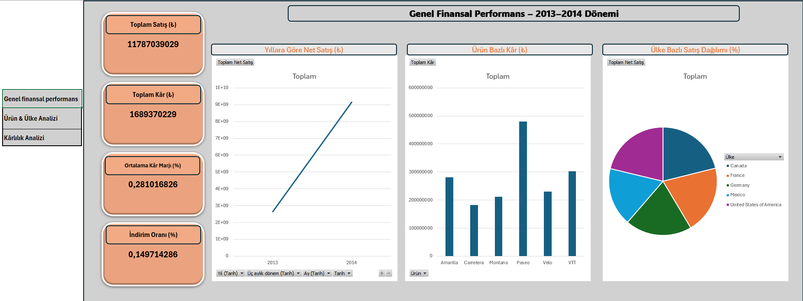

- Product & Country Analysis Dashboard
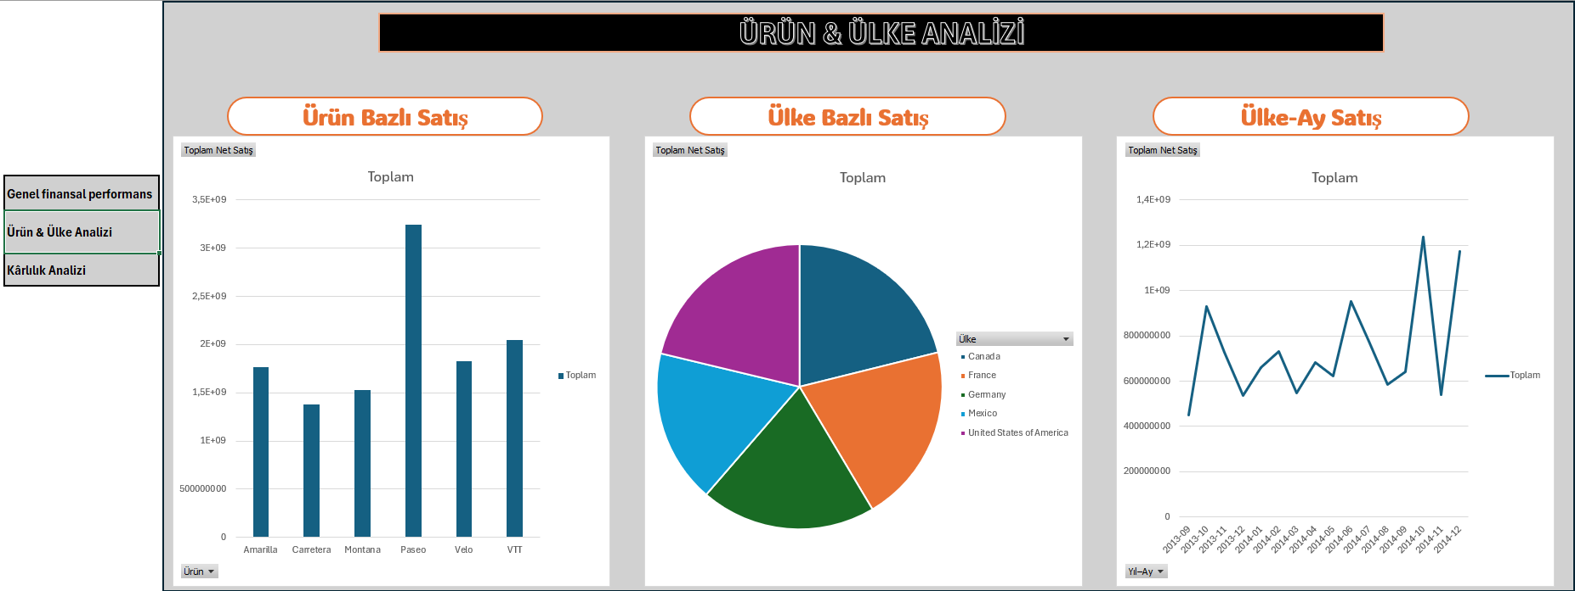
- Profitability Analysis Dashboard
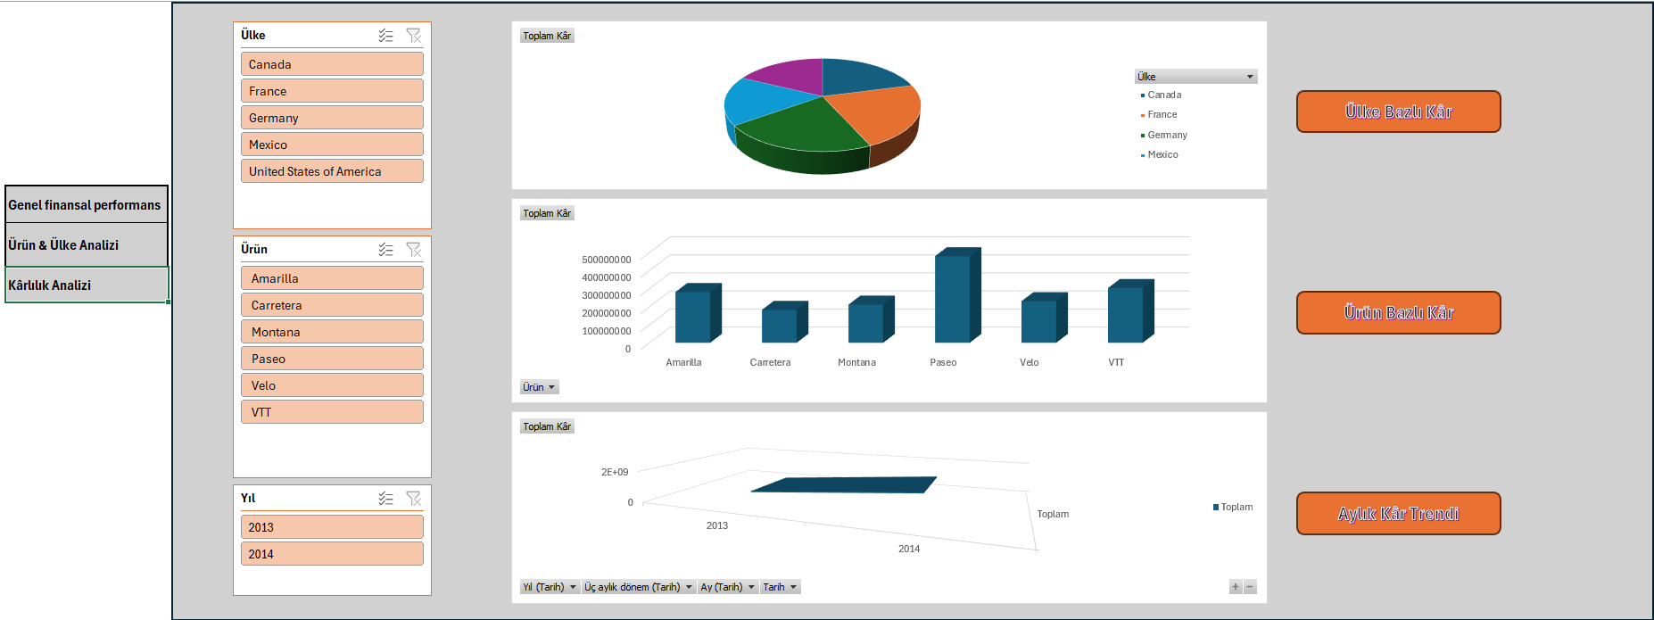
The project documentation and Word report have been structured for portfolio presentation.
The appendices include:
- Example charts and graphics
- Code structure explanations
- Dashboard interface screenshots

